The 4th "Fareast Cup" International Regatta 2019
第4回 極東杯国際ヨットレース2019
Notice of Race （Draft2018.12.30）
レース公示（2018年12月30日案）
Aug. 20th.--Sept.26th, 2019
2019年8月20日～9月26日

The Organizing Authority(OA) is Qingdao Major International Sailing Events (Festivals) Organizing Committee and Chinese Yachting Association supported by Qingdao Municipal Bureau of Sports，Qingdao Olympic Sailing City Development Association，Qingdao Yachting Association, Qingdao Tourism Group and Qingdao Administration Center of Sailing Sport.
Co-organizers（each local OA）: Qingdao Silk Road Sailing Events Management Co., Ltd.(China)；Primorsky Regional Social Organization Sailing Federation (Russia)；and Toyama Sailing Federation(Japan).
主催団体（OA）；青島国際セーリングイベント（フェスティバル）組織委員会､中国ヨット協会
後援；青島市体育局、青島オリンピックセーリング都市開発協会、青島ヨット協会、青島観光グループ、青島セーリングスポーツ管理センター
共催団体（各地域ＯＡ）；青島シルクロードセーリングイベント運営有限会社（中国）、プリモルスキー地域社会組織セーリング連盟（ロシア）、富山県セーリング連盟（日本）。

Rules規則
  - The regatta will be governed by the rules as defined in The Racing Rules of Sailing. 本レガッタには、セーリング競技規則に定義された規則が適用される。
  - World Sailing Offshore Special Regulations will also apply (OSR category 2). ワールドセーリング外洋特別規定も適用される（OSRカテゴリー2）。
  - The prescriptions of the National or Regional Yachting Association will not apply. 各国連盟または地域ヨット協会の規程は適用されない。
  - If there is a conflict between languages, the English text will take precedence. 言語間で矛盾が生じた場合には、英文が優先する。

Advertising広告
  - In accordance with ISAF Regulation 20 (Advertising Code), the race committee may require all boats to display the event sponsor’s advertising on their bows and/or on backstay pennants. ISAF規則20（広告規程）に従って、レース委員会はすべての艇にイベントスポンサーの広告を各艇のバウおよび／またはバックステイにペナントに表示するよう要求することがある。
  - Advertisements of the teams on the racing boats must be approved by the organizing committee. レーシングボートのチームの宣伝は、組織委員会によって承認されなければならない。
  - The race committee has the right to refuse the teams’ advertisements which are against the event sponsor or the local advertising laws. レース委員会は、イベントスポンサーまたは地域の広告法に反するチームの広告を拒否する権利を有する。

Event and Eligibilityイベントと資格
  - The regatta is open to native and international sailors (teams), teams can be from cities, nations and clubs. 本レガッタは、ネイティブおよび国際的なセーラー（チーム）にオープンであり、チームは都市、国家およびクラブから参加できる。
  - For the safety and race organization reason, a tracker and engine working recorder for each boat may be required by the Organizing Authority, each team should keep it working properly during the race. The OA may require each boat to lock its engine with cable lines. 安全性とレースの組織上の理由から、各艇用のトラッカーとエンジン作動記録計を主催団体によって要求される事がある。各チームはそれがレースの間正しく作動し続けるものとする。 OAは各艇にそのエンジンをケーブルラインで固定するよう要求することがある。
  - Hand-held VHF Radio should be brought by each team. 携帯VHF無線機は各チームが持参するものとする。
  - For each team, there could be 7 crews at east and at most 9 crews plus 1 media crew on board. Each team shall have 2 experienced skipper, who’s capable of offshore racing, at least 4 crews who’s experienced offshore racing. CVs of the skippers and crews should be submitted for registration. The 6 persons’ (skippers and crews) qualifications or certificates that must be from MSA China, CYA,RYA, JSF and ASA or from other equivalent organizations should be displayed upon registration. 各チームは、最低7人から最大9人のクルーに加えて1人のメディア担当クルーが乗船する。各チームは、オフショアレースが可能な2人の経験あるスキッパーと、オフショアレースの経験ある少なくとも4人のクルーを持つものとする。スキッパー及びクルーの履歴書は登録のために提出するものとする。 MSAチャイナ、CYA、RYA、JSF、およびASAまたは同等の他の団体からの6人（スキッパーおよびクルー）の資格または証明書は、登録時に提示するものとする。
  - All the sailors must be (over) 18 years old on Aug.20th,2019. 2019年8月20日、すべての船員は18歳以上であること。

Class クラス
One design Class Beneteau First 40 (Provided by the organizing authority) ワンデザインクラスBeneteau First 40（主催団体によって提供される）

On-line Entryオンラインエントリー
  - Eligible teams may enter by completing the entry form (Attachment 1) at http://www.qdsailing.org and send it to FareastCupRegatta@163.com with all the copies of passports or ID cards of all the team members. Entries must be received no later than 24:00hrs, June 20th, 2019.（Foreign sailors need only copies of passports, while Chinese sailors need the copies of both passports and ID cards with both sides） 資格のあるチームは、http://www.qdsailing.orgのエントリーフォーム（別紙1）に記入し、全員のパスポートまたはIDカードのコピーを添えてFareastCupRegatta@163.comに2019年6月20日24時必着で送付すること。（外国人船員はパスポートのコピーだけが必要、中国人船員はパスポートとIDカードの両方のコピーが必要）
  - Receiving the E-mail confirmation letter is considered signing up the entry successfully. 確認のEメールを受け取ると、エントリーに正常にサインアップしたと見なされる。

On-site Registrationオンサイト登録
A team leader of each eligible team shall provide these following documents at registration: 各適格チームのチームリーダーは、登録時に以下の書類を提出しなければならない。
  - A copy of the entry confirmation. エントリー確認のコピー
  - Passports or ID cards (the original and the scanned copy) of all the team members. すべてのチームメンバーのパスポートまたはIDカード（原本とスキャンしたコピー）。
  - Equipment damage deposit. 機器損傷デポジット
  - Proof of personal accident insurance complying with NOR 23. NOR 23に準拠した個人傷害保険の証明。

Fees料金
  - Each team needs to pay equipment deposit of $2,000. (Or equal RMB with exchange rate on the day). 各チームは2,000ドルの備品保証金を支払う必要がある。 （またはその日の為替レートと人民元を等しくする）。
  - The equipment damage deposit should be paid in cash at registration. 機器損傷保証金は、登録時に現金で支払う必要がある。

Format of Raceレースの形式
The regatta will consist of offshore races and inshore races. レガッタは、オフショアレースとインショアレースで構成されます。

Scheduleスケジュール
  - The schedule is as the following: スケジュールは以下の通りである。
6.22 | SAT | Boats Drawing(by email or we-chat)  艇の抽選（Eメールまたはチャットによる）
8.20 | TUE | QD Hotel check in; registration; boat preparation;shopping  青島ホテルにチェックイン、登録、準備、買い物
8.21 | WED | Registration; boat preparation;practice;shopping
8.22 | THU | Registration; boat preparation;practice;shopping
8.23 | FRI | 13:30 Skippers’ Meeting, Safety Training; Preparation  艇長会議、安全講習、準備
8.24 | SAT | Inshore Races(3races) in Qingdao;18:30 Opening Ceremony  青島インショアレース（3レース）、18時30分開会式
8.25 | SUN | Reserve Day for Inshore races インショアレース予備日
8.26. | MON | Starting Ceremony/ Offshore Race I to Vladivostok 出発式、スタート
8.27-9.2 | All days | Offshore Race I （7days) オフショアレースⅠ（7日間）
9.3 | TUE | Arriving at Vladivostok, Russia ; CIQ（immigration）  ロシア・ウラジオストック到着、CIQ（入国手続）
9.4 | WED | Joining the local activities,including the local regatta organized by Seven Feet Club 地元行事参加、セブンフィートクラブによるレースを含む
9.5 | THU | Inshore races (3races) in Vladivostok ウラジオストック・インショアレース（3レース）
9.6 | FRI | Reserve Day for inshore races インショアレース予備日
9.7 | SAT | Emigration / Offshore Race II to Toyama 出国手続き、オフショアレースⅡ 富山へ
9.8-9.11 | All days | Offshore Race II (4days) オフショアレースⅡ（4日間）
9.12 | THU | Arriving at Toyama, CIQ(immigration) 富山到着、CIQ（入国手続き）
9.13 | FRI | Lay day( Joining local activities) 休養（地元行事参加）
9.14 | SAT | Inshore races(3races) in Toyama インショアレース・富山（1レース 調整中）
9.15 | SUN | Reserve day for inshore races インショアレース予備日（観光、休養で調整中）
9.16 | MON | CIQ（emigration）；Offshore Race III to Qingdao CIQ（出国手続き）、オフショアレースⅢ
9.17-9.23 | All days | Offshore Race III (7days) オフショアレースⅢ（7日間）
9.24 | TUE | Arriving in Qingdao, Boats delivery & deposit refund. 青島到着、艇の引き渡しおよびデポジット返却
9.25 | WED | Awarding and Closing Ceremony 表彰式、閉会式
9.26 | THU | Departure (Check out) 帰国（チェックアウト）

  - No more than three races are scheduled for inshore races per day. 一日あたりのインショアレースは3回以下が予定されている。
  - Totally 9 inshore races are scheduled (including 3 races separately in each city). 合計9回のインショアレースが予定されている（各都市で3回のレースを含む）。

Equipment and Measurement装備および計測
  - The Organizing Committee will provide about 9 to 10 boats ( Beneteau First-40). All teams shall join the boats drawing on June 22ndby email or we-chat. 組織委員会は9〜10隻のボートを提供する（Beneteau First-40）。すべてのチームは6月22日の艇抽選にEメールまたはチャットで参加しなければならない。
  - Cash deposit would be returned in full if the boats are undamaged in any way after the Regatta. Otherwise, teams should pay for the repairing of the damaged equipment and the cost of it will be deducted from the equipment deposit. The organizing authority has the right to demand indemnification if the deposit is not sufficient. 艇がレガッタ後に損傷を受けていない場合、デポジットは全額現金で返金される。もしそうでなければ、チームは損害を受けた機器の修理の代金を支払わなければならない、そして、それのコストは機器の保証金から差し引かれる。保証金が十分でない場合、主催団体は補償を要求する権利を有する。
  - The organizing authority will be responsible for inspecting all boats; if necessary an equipment inspection may be taken at any time during racing. 主催団体はすべての艇を検査する責任があり､必要に応じて、レース中いつでも装備の検査をすることができる。

Sailing Instructions帆走指示書
The Sailing Instructions will be available after the on-site registration. 帆走指示書は、現地での登録以降に入手できる。

The Venue 開催地
Attachment 2 are the venues located in Qingdao, Vladivostok and Toyama. 別紙2は青島、ウラジオストク、富山にある開催地である。

The Courseコース
Please see the Sailing Instructions. Attachment 3 is for Offshore racing. 帆走指示書を参照のこと。別紙3はオフショアレース用である。

Penalty Systemペナルティ方式
  - Rule 44.1 is changed so that the Two-Turns Penalty is replaced by the One-Turn Penalty. 2 規則44.1を変更し、2回転のペナルティを1回転のペナルティに置き換える。
  - Decision of the jury will be final as provided in rule 70.5. 規則70.5で規定される通り、ジュリーの判決が最終となる。

Scoring得点
    - The scoring of the total results will be the total of offshore-race results of three legs ( 1st leg-Qingdao to Vladivostok; 2nd leg- Vladivostok to Toyama ;3rd leg –Toyama to Qingdao) plus 9 inshore-races results, in which each offshore race will be double scores. If there is a tie in total results, the ties shall be broken first in favour of the boat(s) with the best score(s) in the offshore- race III; If offshore race III hasn’t been finished, the ties shall be broken in favour of the boat(s) with the best score(s) in the offshore race II; if offshore race II hasn’t been finished, the tie shall be broken in favour of the boat(s) with the best score(s) in the offshore race I. The results of the offshore races shall not be excluded. 総合成績の得点はオフショアレースの3つのレグ（第1レグ - 青島からウラジオストック、第2レグ - ウラジオストクから富山、第3レグ – 富山から青島）の得点に、9つのインショアレースの結果を加えたものとする。オフショアレースはダブルスコアとする。総合成績の得点が同点である場合、オフショアIIIで最高得点を得た艇を勝ちとしてタイを解く。オフショアレースIIIが終了していない場合は、オフショアレースIIで最高得点を得た艇を勝ちとしてタイを解く。オフショアレースIIが終了していない場合は、オフショアレースIで最高得点を得た艇を勝ちとしてタイを解く。オフショアレースの結果は除外されない。
  - Three inshore races and one offshore race are required to be completed to constitute a series. When 4 inshore races are finished, one worst score shall be excluded. When 8 inshore races are finished, two worst scores shall be excluded. シリーズの成立には、3回のインショアレースと1回のオフショアレースを完了する事が必要である。 4回のインショアレースが完了した場合、最も悪い得点が除外されなければならない。 8回のインショアレースが完了した場合、最も悪い方から2つの得点が除外されなければならない。

Berthing停泊
Boats shall be kept in their assigned places at the pontoons during the regatta. 艇はレガッタの間、ポンツーンの割り当てられた場所に保管されなければならない。

Haul-Out Restrictions 上架制限
Boats shall not be hauled out during the regatta except with and according to the terms of prior written permission of the race committee. 艇は、レース委員会の事前の書面による許可があり、その条件に従っている場合を除き、レガッタ期間中上架してはならない。

Diving Equipment and Plastic Pools 潜水用具とプラスチックプール
Underwater breathing apparatus and plastic pools or their equivalent shall not be used around keel boats between the preparatory signal of the first race and the end of the regatta. 最初のレースの準備信号からレガッタ終了までの間、水中呼吸器具､プラスチック製プールまたはそれらに類するものは使用してはならない。

Radio Communication 無線通信
During racing, the Race Committee official channel is VHF81 for inshore communication, and the spare channel is VHF 72. All boats shall listen to channel VHF16 during the offshore races. Each team needs to bring her own hand-held VHF Radio during the regatta. レース中、レース委員会の公式チャンネルは沿岸通信用にVHF81で、予備チャンネルはVHF 72である。すべての艇はオフショアレース中はチャンネルVHF 16を聴取しなければならない。各チームはレガッタ期間中､自艇用に携帯VHF無線機を持参する必要がある。

Photography Consent 写真の同意
By participating in this event, competitors automatically grant the organizing authority and the event sponsors the right, in perpetuity, to make, use, and show, at their discretion, any photography, audio and video recordings, and other reproductions of them made at the venue or on the water from the time of their arrival at the venue, until their final departure, without compensation. このイベントに参加することで、レース参加者は、開催地に到着した時から出発するまで、補償なしで、開催地または海上で作成されるどのような写真、音声およびビデオの記録ならびに他のそれらの複製を裁量で作成、使用および表示する権利を永久に主催団体およびイベントスポンサーに自動的に認めることになる。

Prizes 賞
Prize money will be awarded: 賞金が授与される。
The First Place: US Dollar 10000, 1位： 10000米ドル
The Second Place: US Dollar 5000, 2位：5000米ドル
The Third Place: US Dollar 3000 3位：3000米ドル

Disclaimer of Liability 責任の否認
  - Competitors participate in the regatta entirely at their own risk. See rule 4, Decision to Race. The organizing authority will not accept any liability for material damage or personal injury or death sustained in conjunction with or prior to, during, or after the regatta. レース参加者は完全に自分自身の責任でレガッタに参加する。規則4「レースをすることの決定」を参照のこと。主催団体は、レガッタの前後あるいは期間中に生じた物的損害または人身傷害もしくは死亡によるいかなる責任も負わない。
  - All the people on board must sign the Disclaimer of Liability. 乗艇するすべての者は、責任の放棄に署名しなければならない。

Insurance 保険
Each participant must have valid personal accident insurance with the minimum insurance cover of 100,000 dollars per incident. Original insurance document and its photocopy should be displayed during the registration, if not, 100 dollars are required for insurance purchasing. Those who do not provide the Original insurance document or purchase the insurance at on-site registration may be banned to participate by the organizing authority. 各参加者は、1インシデントあたり最低保険金10万ドルの有効な個人傷害保険を持っている必要がある。登録時に保険証書原本とそのコピーを表示する必要がある。表示されない場合は、保険購入に100ドルが必要である。原本の保険証を提示しないか、または現地の登録で保険を購入しない人は、主催団体により参加を禁止されることがある。

Accommodation for Participants 参加者のための宿泊施設
  - Lodging (standard or double room[twin room] or Korean ondol or Japanese tatami[3-4persons]) in Qingdao, Vladivostok and Toyama will be arranged by each local organizing authority from Aug. 20th- Sept.28th (till 12:00 noon).The lodging fee will be paid by each local organizing authority. Meals [lunch & supper]on the shore (including inshore races day) will be arranged and paid by each local organizing authority except breakfast offered free by the hotels. If any sailor expects to live in a single room or say a room by one person, he or she shall report to the OA for registration in advance and the room fee will be paid by himself or herself. 青島、ウラジオストク、富山の宿泊（スタンダードまたはダブルルーム[ツインルーム]、韓国のオンドルまたは日本の畳[3〜4人]）は、8月20日から9月28日まで（12:00まで）各地方主催団体により手配される。宿泊費は各地方主催団体により支払われる。陸上での食事（昼食＆夕食）（インショアレース日を含む）は、ホテルが無料で提供する朝食を除き、各地方主催団体が手配し支払う。シングルルームを希望する、または1人での部屋を要求するセーラーは、事前に登録のためにOAに報告し、その部屋代は自分で支払う必要がある。
  - A damage deposit of $ 50 for each participant by cash may be charged by the hotel and will be refunded if no damage occurs. 参加者1人あたり50ドルの現金でのダメージデポジットがホテルより請求される場合があり、損害が発生しない場合は返金される。

Others その他
  - Each team shall bring a flag of their team/club or their national authorities to the Organizing Authority. 各チームは、自分のチーム/クラブまたは各国連盟の旗を主催団体に持参するものとする。
  - The Organizing Authority may appoint maximum two journalists on each boat to take photos and video. Skippers shall be responsible for the safety of the journalists on board and supervise the work of the journalists on board. 主催団体は、写真やビデオを撮るために各艇に最大2人のジャーナリストを任命することができる。船長は、船上のジャーナリストの安全に責任を持ち、船上のジャーナリストの仕事を監督するものとする。
  - All foreign sailors shall hold two times effective visas to enter P.R. China. Each team shall submit the scanning copies to the OA of their competitors’ passports (the page with a photo) and two times effective visas. If any team needs to swap competitors when they arrive at Vladivostok, Russia and Toyama, Japan, the related information about swapping sailors shall be delivered to the OA before the entry. All sailors entering the free port of Vladivostok and Toyama need to have the valid electronic visas or paper visas or visas free(All teams are required to check and apply for the visas at each Russian and Japanese embassy or consulates beforehand.) すべての外国人セーラーは、中国に入国するために2回有効なビザを保有しなければならない。各チームは、パスポートの写真付きのページと2回有効なビザのコピーを提出しなければならない。ロシアのウラジオストクと日本の富山に到着したときに、どのチームも競技者を入れ替える必要がある場合は、セーラーの交換に関する関連情報をエントリー前にOAに送付しなければならない。ウラジオストクと富山のフリーポート？に入国するすべてのセーラーは、有効な電子ビザまたは紙ビザまたはビザフリー？を持っている必要がある（すべてのチームは、事前にロシアと日本の各大使館または領事館でビザの確認と申請をする必要がある）。
  - CIQ documents needed： 必要なCIQ書類
The scanning copies of passports with photos and the Visas pages 写真付きのパスポートとビザのスキャンコピー
  - During racing, swapping sailors are not permitted unless the request party submits an application in a written form and gets the approval of the OA. Or there are some unexpected special problems occurring, they can swap sailors upon receiving the approval of the RC. レース中は、要請当事者が書面で申請書を提出し、OAの承認を得ない限り、セーラーの交換は認められない。あるいは、予期せぬ特別な問題が発生している場合、RCの承認を受けて船員を交換することができる。
  - For further information, please contact: 詳しくは下記までご連絡ください。
Qingdao Organizing Authority: 青島主催団体
Name: Xin Kejiang, Meng Yuejiao,
Fax: +86 (0)532 8591 6115
Tel: +86 (0)532 8591 6115, +86 (0)532 5870 2691
E-Mail: FareastCupRegatta@163.com
Address: Room 1616, No.17 Xianggang Zhong Road, Qingdao, China,
Post Code: 266071

Organizing Committee
2018.12.30

Attachment 1:
ENTRY FORM
"Fareast Cup" International Regatta 2019
Aug20th--Sept26 2019
Cities/nations / clubs：
 |  | First  Name | Given Name | Gender | Date of Birth |  | Mobile Phone | Nationality |  |  |  | Passport No./  ID NO. | Issuing Date | Expiry
 |  |  |  |  | (DD/MM/YY)
SKIPPER
Crew 1
Crew 2
Crew 3
Crew 4
Crew 5
Crew 6
Crew 7
Crew 8
Media Crew
I will be governed by the rules as defined in the Racing Rules of Sailing (RRS), Sailing Instructions and class special rules. I acknowledge that the Organizing Authority will not be responsible for participators’ life or injury or any damage of equipment. I declare that during the competition I have valid insurance with the minimum insurance cover of 100,000 dollars. So does my team.
Location: |  |  |  | date: |  | Sign:
The above statement must be signed.
Permission from your national or local department in charge

(Stamp)

Attachment 2: 4th "Fareast Cup” International Regatta 2019
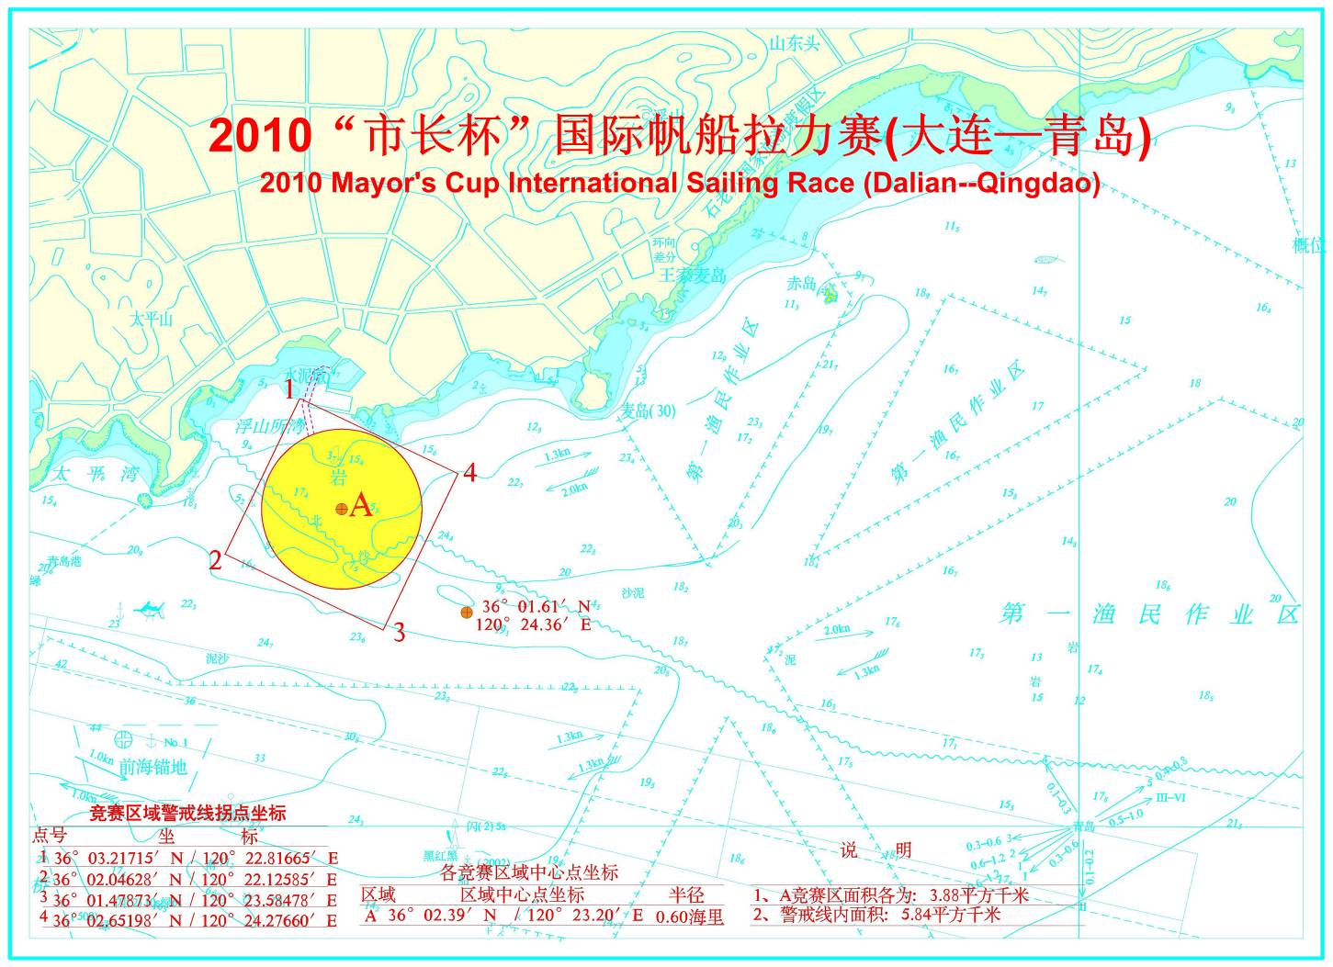
Qingdao Olympic Sailing Center(N 36°03.427’； E120°23.410’)

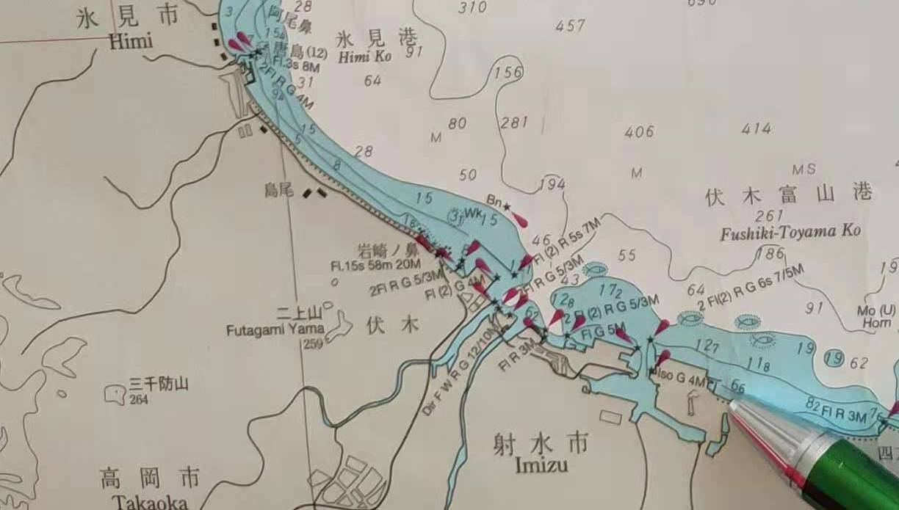
Toyama Marina, Japan (N 36°46.240’； E137°08.283’)
Inshore race（N 36°47.147’； E137°06.677’)
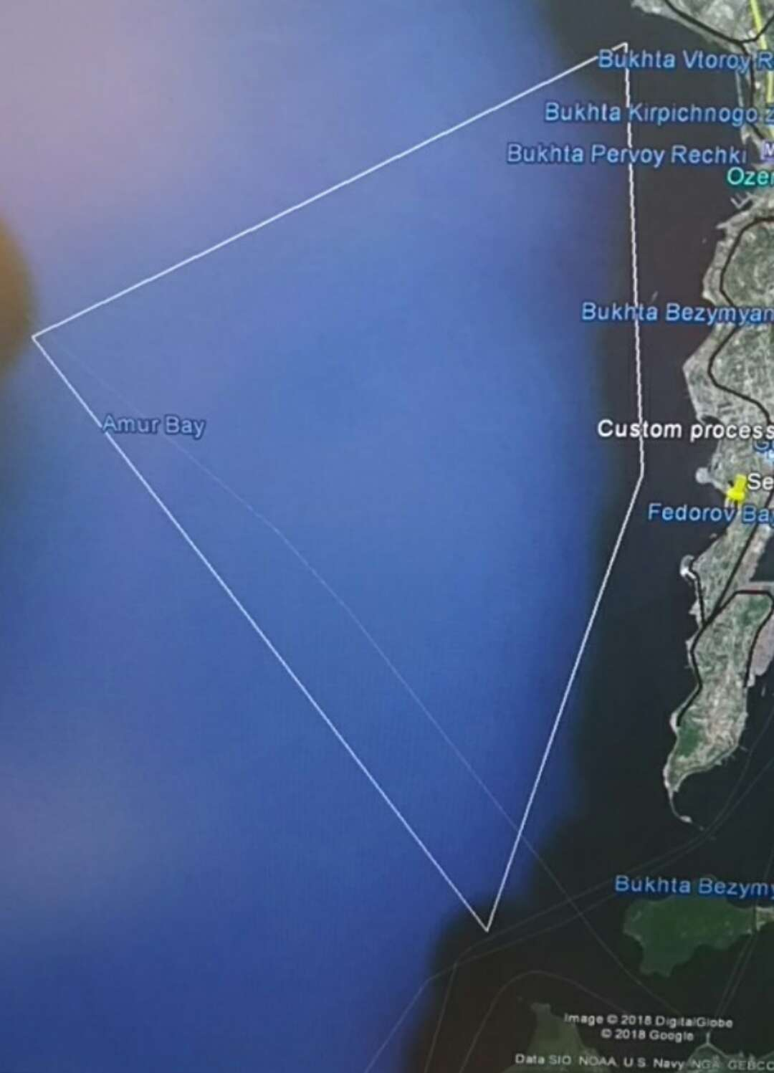
Seven Feet Club, Vladivostok, Russia(N 43°06.499’； E131°52.354’)
Immigration & Emigration Berthing( N 43°06.670’； E131°53.160’)
Inshore Race(N 43°03.154’； E131°54.346’)

Attachment 3 Offshore Races(3 legs)

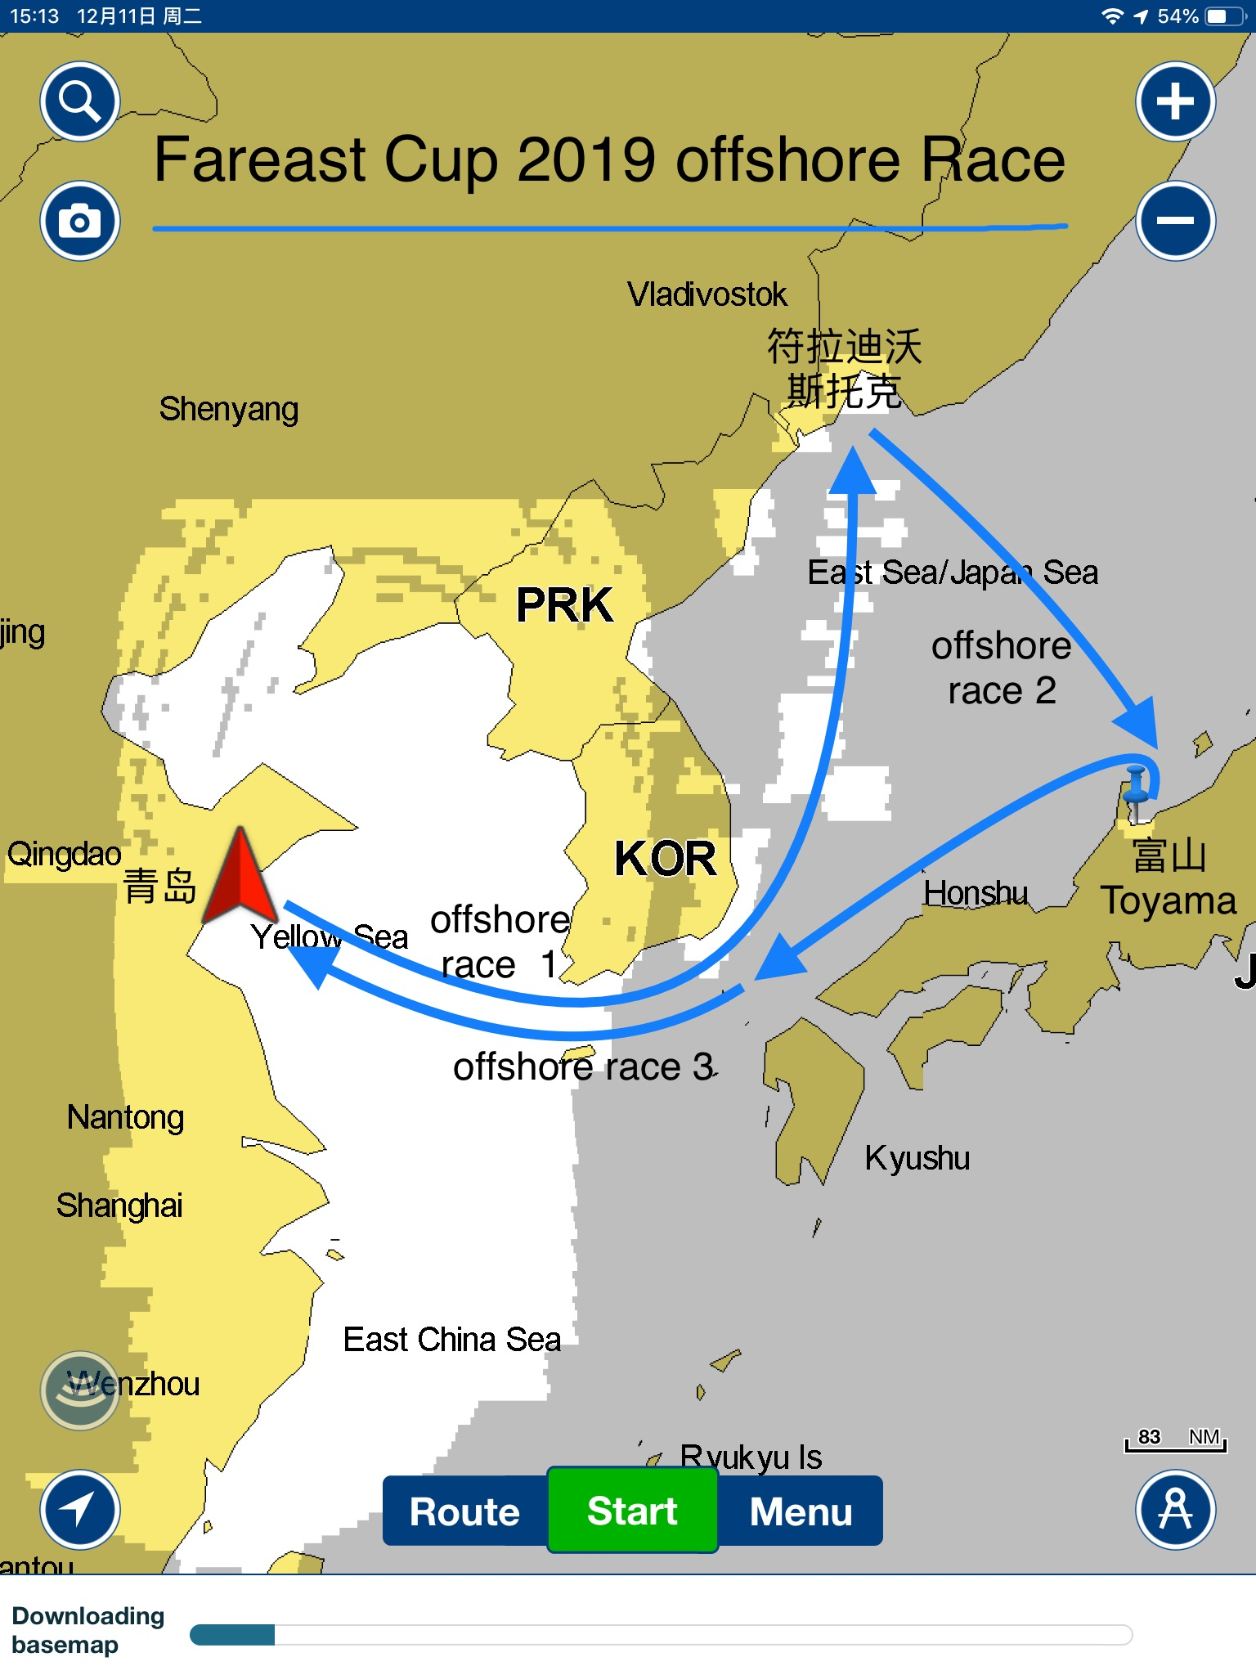
Offshore Race I: From Qingdao, China to Vladivostok, Russia
Offshore Race II: From Vladivostok to Toyama, Japan
Offshore Race III: From Toyama to Qingdao, China

